Business Data Analysis and Reporting using AWS and Machine Learning
In real companies, business data comes from web portals and gets stored in databases.
But managers and non-technical people cannot understand raw data or ML outputs.
the goal of this project is:
- Take business data from web portal
- Process and analyze it using ML
- Convert final output into PDF and Excel reportsx
- So that anyone can understand the result easily

Architecture:
→ Web Portal (PHP + Apache on EC2)
→ RDS MySQL (Business Data)
→ EC2 (Python + ML Processing)
→ S3 (Data Lake & Reports)
→ PDF / Excel Reports
Service Used: Amazon VPC
Why we used it:
To create our own private network inside AWS
To isolate our resources from public internet
For what purpose:
EC2 and RDS should not be open to everyone
Control inbound and outbound traffic
Follow real-time security architecture
Go to VPC Dashboard → Create VPC.
Set IPv4 CIDR block (e.g., 10.0.0.0/16).
Create subnets (public for EC2, private if needed).
Create an Internet Gateway and attach it to your VPC.
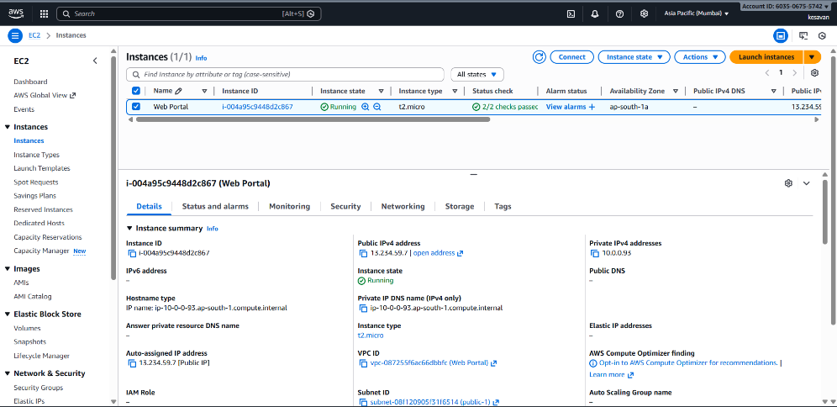

Service Used: Amazon EC2
Why we used it:
To host the web portal
To run Python ML scripts
To act as a processing server
For what purpose:
Web portal runs on EC2 (Apache + PHP)
Python scripts extract data
ML model runs on EC2
Reports are generated from EC2
Go to EC2 Dashboard → Launch Instance.
Name: WebPortalServer
AMI: Ubuntu Server 22.04 LTS
Instance type: t2.micro
Key pair: Select or create a new key
Network settings:
VPC: web-portal-vpc
Subnet: web-public-subnet
Auto-assign public IP: Enable
Security Group:
Allow HTTP (80), SSH (22), HTTPS (443)
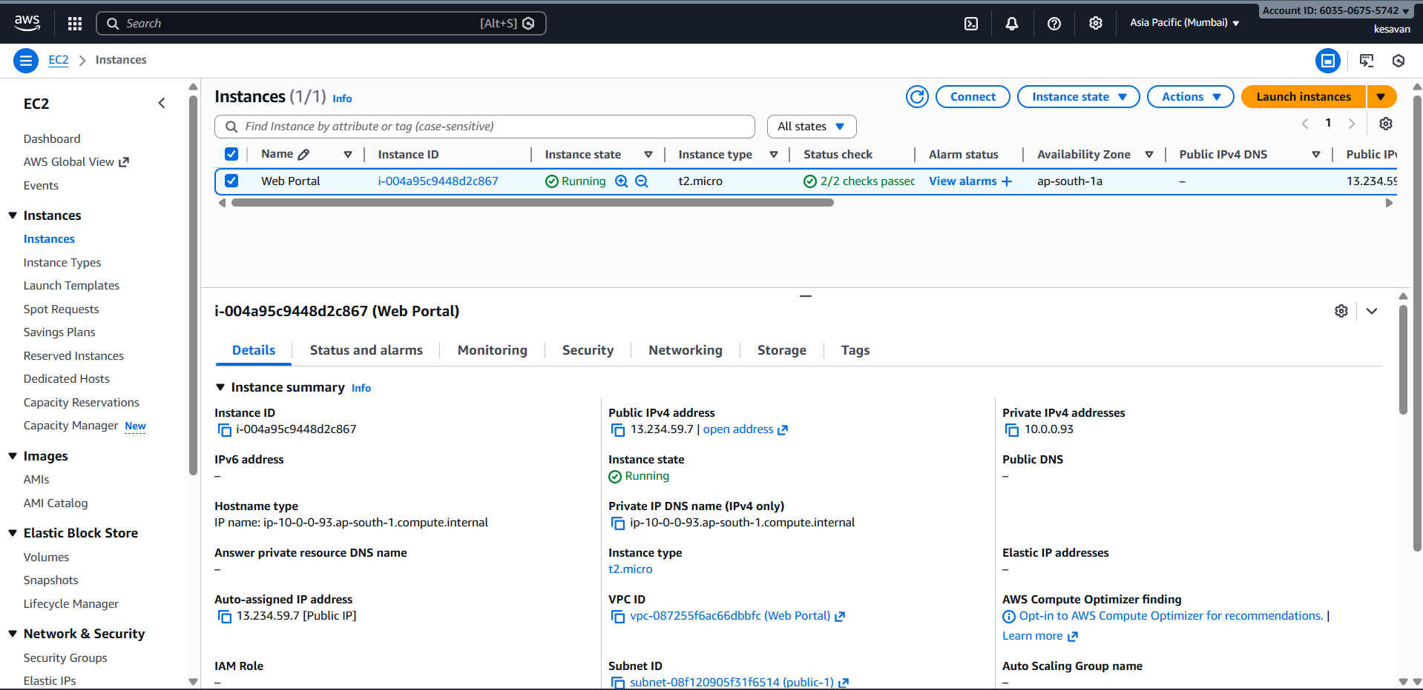
Apache & PHP;
Why we used it:
To create a simple web portal
For what purpose:
Users can enter sales data
Data gets stored into database
This simulates real company web portals.
sudo apt update
sudo apt install apache2 php php-mysql mysql-client python3 python3-venv -y
sudo apt install apache2 -y
sudo systemctl start apache2
sudo systemctl enable apache2
sudo apt install php php-mysql -y
sudo systemctl restart apache2
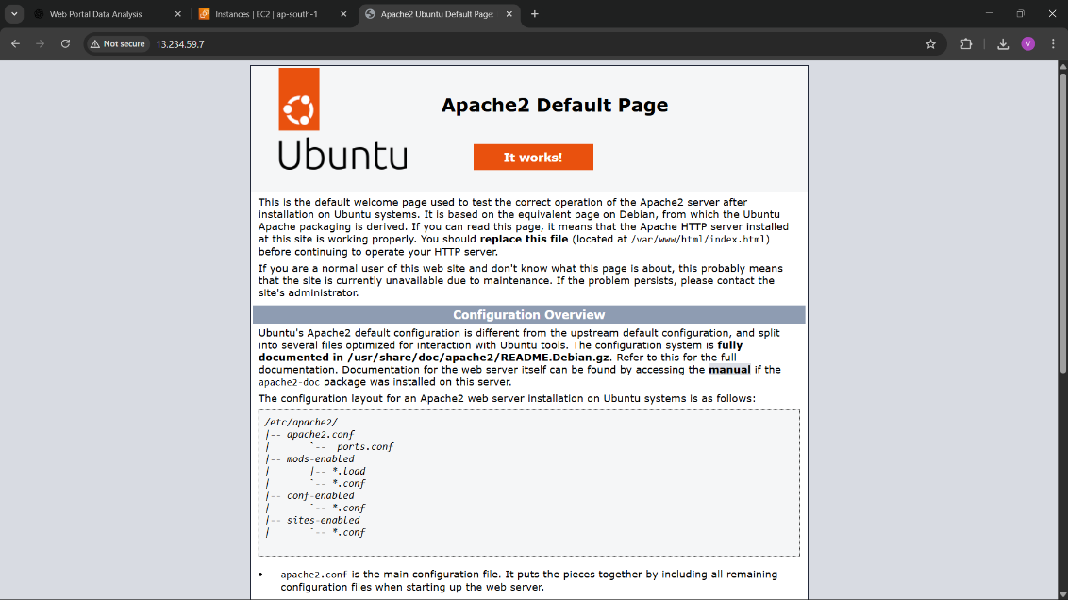
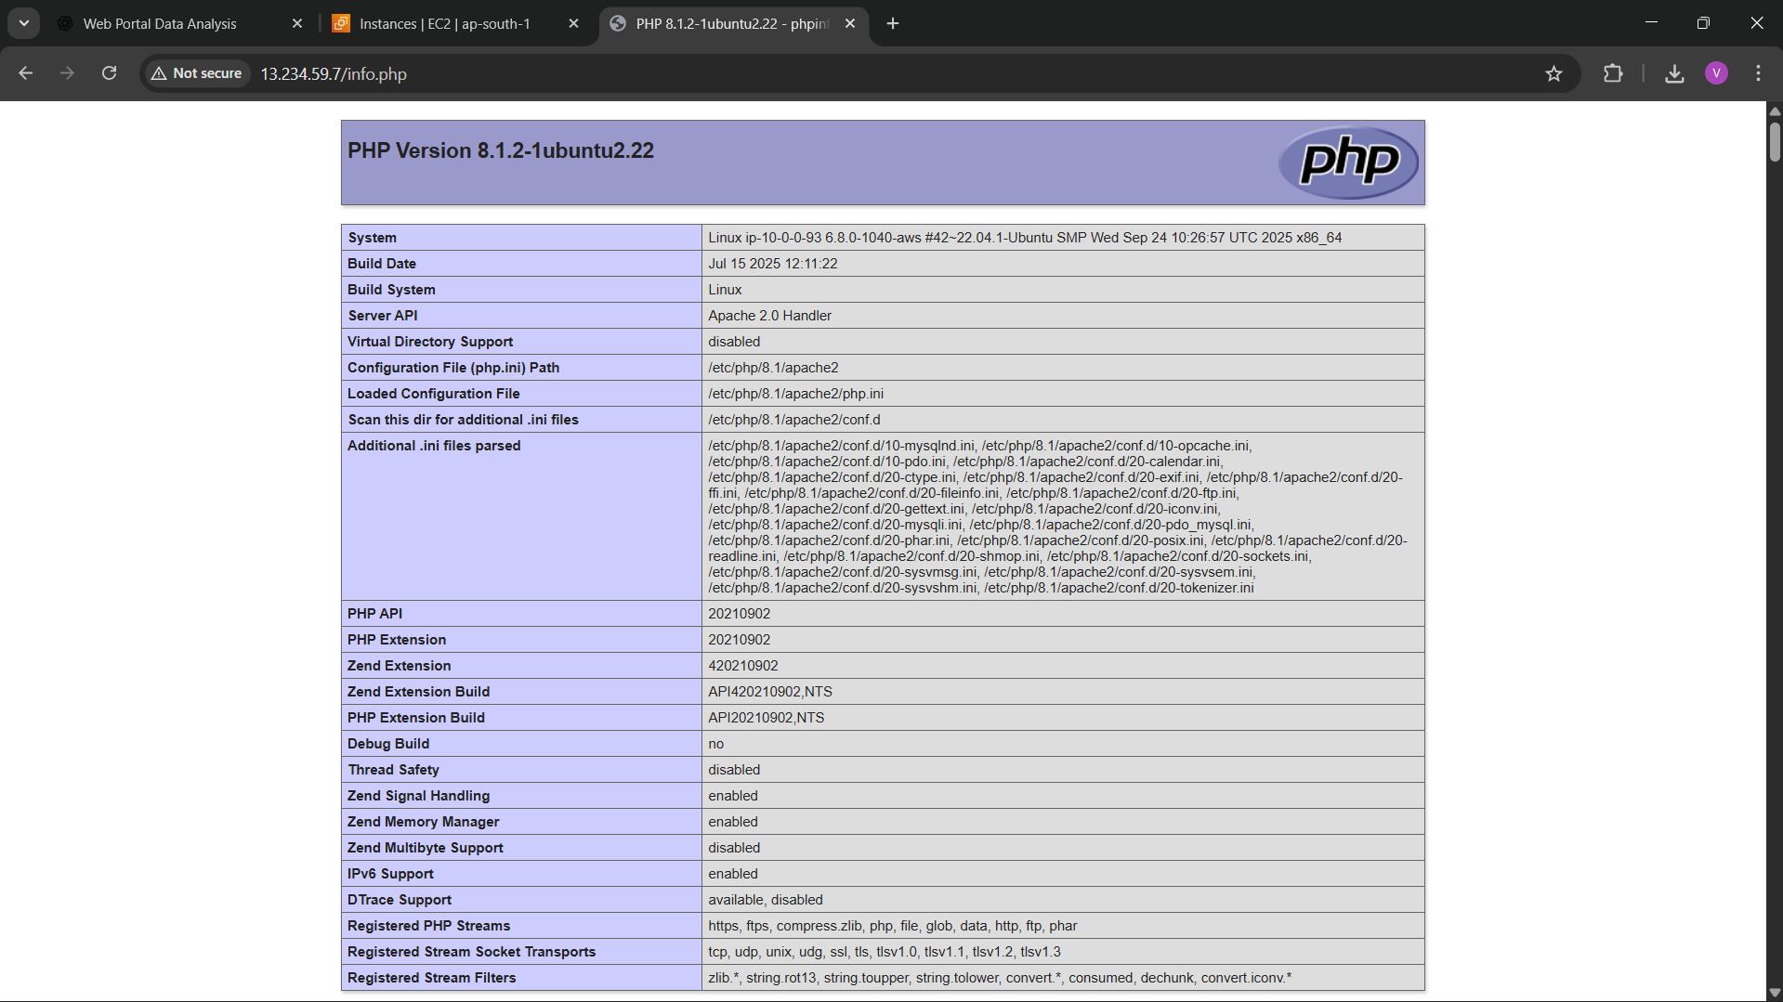
Web Portal Development
- Created a simple PHP web portal
- Portal connects to RDS MySQL
- Used PHP MySQLi for database connection
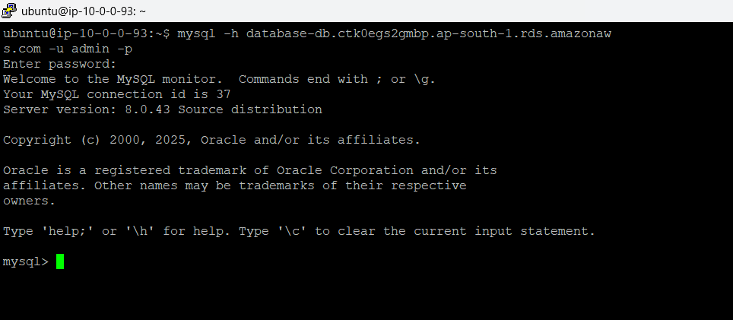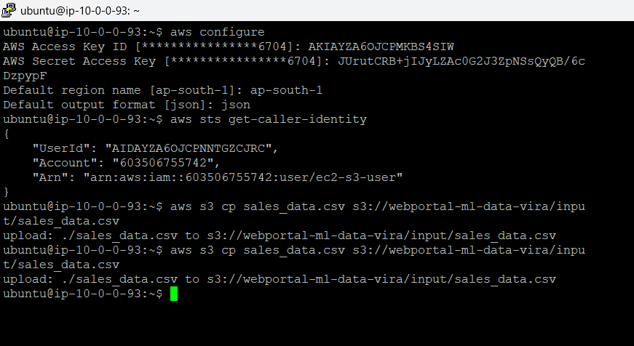

Service Used: Amazon RDS (MySQL)
Why we used it:
To store business data securely
To avoid managing database manually
For what purpose:
Sales data stored in structured format
Supports SQL queries
Easy integration with EC2
Create RDS Database
Engine: MySQL
Instance Type: db.t3.micro
Public Access: No
VPC: Same VPC
Subnet Group: Private Subnets
Security Group:
Allow MySQL (3306) only from EC2 Security Group
sudo apt install mysql-client -y
mysql -h database-db.ctk0egs2gmbp.ap-south-1.rds.amazonaws.com -u admin -p
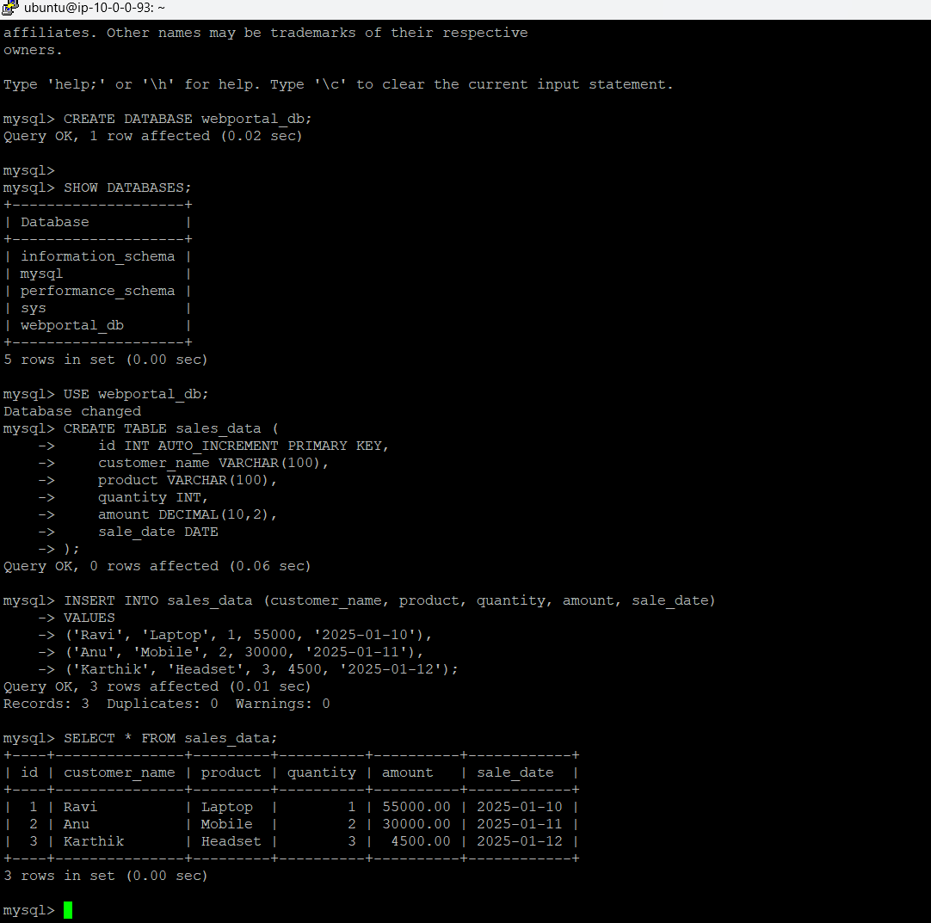
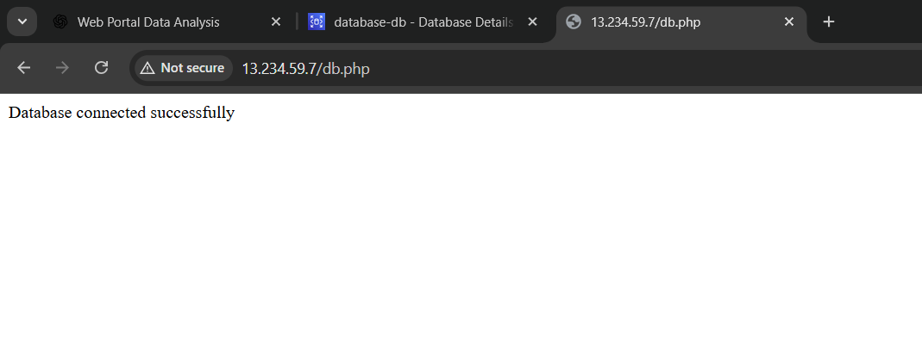
Service Used: AWS IAM
Why we used it:
- To control access between AWS services
For what purpose:
- EC2 can access S3 securely
- Avoid hardcoding credentials
- Follow security best practices
Why we use Amazon S3?
- Service Used: Amazon S3
- Why we used it:
- To store large data and reports
- To act as a data lake
- For what purpose:
- Input CSV data stored in S3
- Output ML results stored in S3
- PDF & Excel reports stored in S3
S3 is used as central storage.
aws s3 mb s3://webportal-ml-data-vira
aws s3 ls s3://webportal-ml-data-vira/
aws s3 cp sales_data.csv s3://webportal-ml-data-vira/input/sales_data.csv
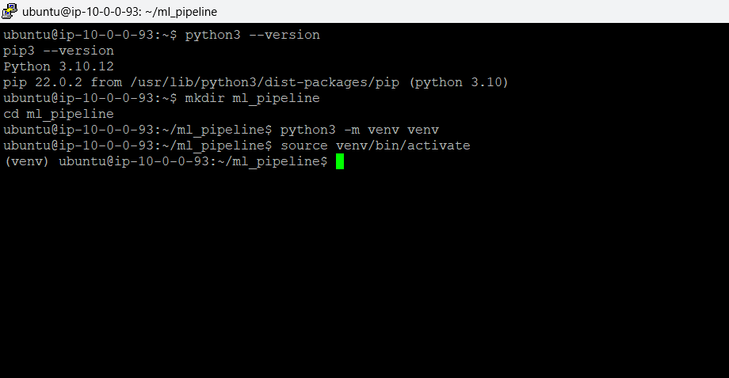

Why we use Python?
Why we used it:
- Easy for data analysis and ML
- Supports many libraries
For what purpose:
- Read CSV data
- Analyze sales data
- Train ML model
- Generate reports
Python is used as processing language.
python3 -m venv venv
source venv/bin/activate
pip install pandas boto3 scikit-learn matplotlib fpdf openpyxl
python sales_analysis.py
aws s3 ls s3://webportal-ml-data-vira/output/
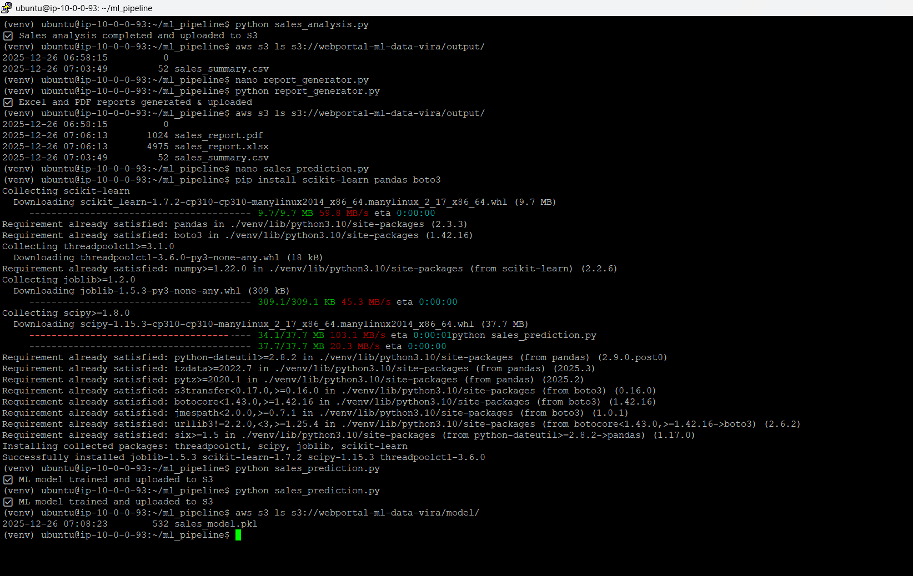

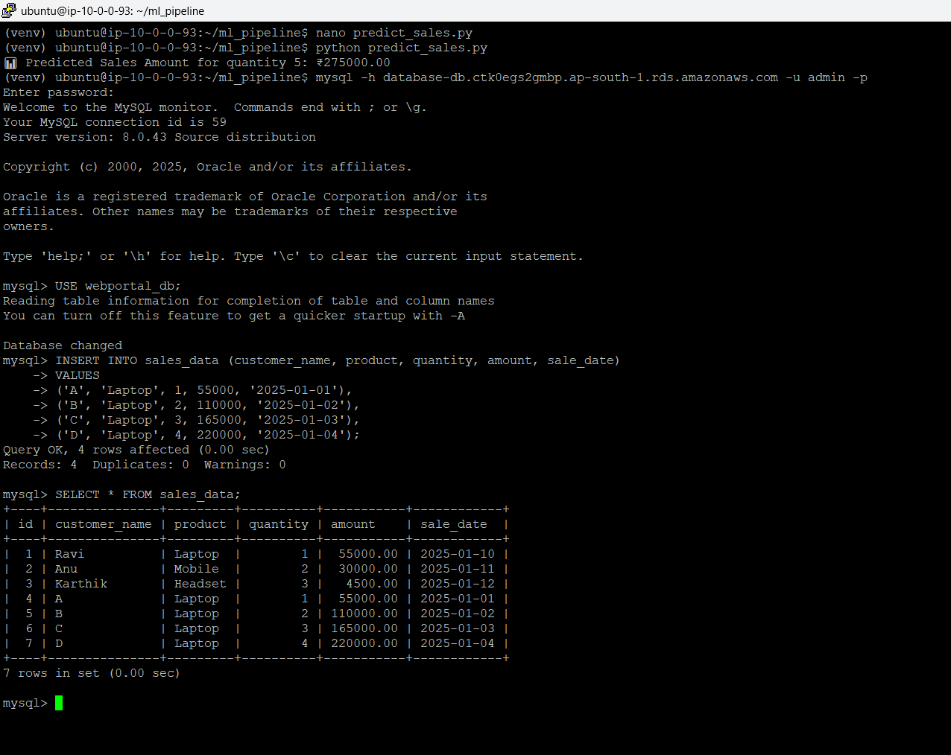
Why we use Machine Learning?
ML Model: Linear Regression
Why we used it:
- Simple and easy to explain
- Works well for numerical prediction
For what purpose:
- Predict sales amount based on quantity
- Identify business trends
ML converts raw data → insights.
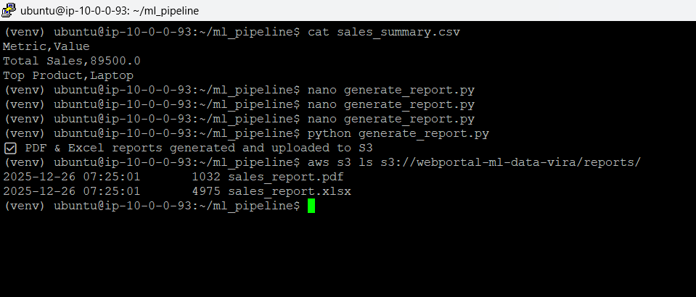

python predict_sales.py
OUTPUT;
Predicted Sales Amount for quantity 5: ₹275000.00
INSERT INTO sales_data (customer_name, product, quantity, amount, sale_date)
VALUES
('A', 'Laptop', 1, 55000, '2025-01-01'),
('B', 'Laptop', 2, 110000, '2025-01-02'),
('C', 'Laptop', 3, 165000, '2025-01-03'),
('D', 'Laptop', 4, 220000, '2025-01-04');
Why we generate PDF & Excel reports?
Why we used it:
- Business users don’t understand ML outputs
- They need readable reports
For what purpose:
- PDF → management reports
- Excel → further analysis
Report contains:
- Total Sales
- Top Product
This is the final business deliverable.
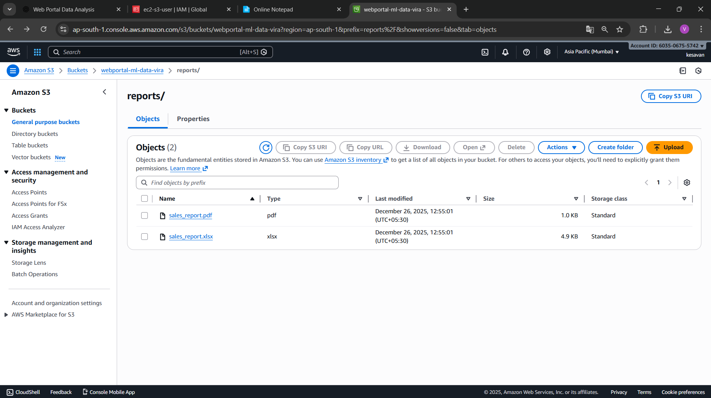

python generate_report.py
aws s3 ls s3://webportal-ml-data-vira/output/
Final Output in S3;
sales_summary.csv
sales_report.pdf
sales_report.xlsx

